Assignment – Organisational Culture

Analyse the culture in the organisation in which you work.

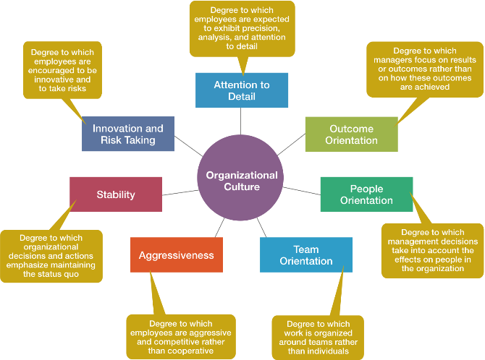

- Set the scene: what is the industry, what does the organisation do or make, its size and any other factors you consider to be relevant.
- Give your interpretation of what each section above means. E.g. what does ‘Stability’ mean etc.
- Under each of the sections in the diagram above, rate your organisation on a scale 1-10 and then outline with specific real examples from your organisation why you gave it that rating.
- Overall what is your view of the organisation’s culture, what suggestions for cultural change would you recommend.

Due date: Tuesday, November 12, by 23:55.

Requirements: Answer should be at circa 2000 - 2500 words– It is not necessary to name the organisation; you may also use diagrams/photos if this is helpful to your overall answer.

Note: Plagiarism will result in zero marks

Marking: This assignment constitutes 15% of the overall marks for the course and will be marked using the following criteria:
1. Prompt: the assignment responds to the writing prompts and includes specific examples; opinions expressed are supported.
2. Organisation: the assignment is clearly organized and easy to follow; there is an introduction, main body and a conclusion; paragraphs are coherent.
3. Engagement: the assignment demonstrates engagement with relevant academic sources and class resources.
4. Style and mechanics: Typed Microsoft Word (Times New Roman font, size 12, 1.5 or double line spacing; the assignment is devoid of grammatical errors, its language is concise, and references are included as appropriate. (See Harvard Referencing Guide).

Marking Scheme
Requirement | Overall Mark
Structure: As per guidance provided, Layout, logical, topic headings, referencing, overall presentation: visual material, grammar, spelling and overall impact etc. | 10%
Total for this Section | 10%
Introduction  - Set out the aims of the assignment and signpost how your argument will unfold  - Introduce the issue and give any essential background information including a brief description of the major debates that lie behind the question.  - Clearly describe what your essay is trying to do and define any essential terms | 2%  6%  2%
Total for this section | 10%
Overall content:  - Analysis of information  - Evidence of understanding of subject  - Present an argument that is balanced  - Present evidence using references to the original published work using Harvard referencing. | 10%  40%  10%  5%
Total for this section | 65%
Conclusions and recommendations:  - summarise the key elements of your argument clearly and concisely  - demonstrate how you've answered the question | 6%  9%
Total for this section | 15%
Total awarded | 100%

